Rope-Tek™ WRD is a range of high-performance lubricants, specifically designed to lubricate and protect steel wire ropes. Each product is formulated from high-performance base oils and thickeners, and contains an advanced additive system that minimises friction and wear, delivering outstanding corrosion protection.

Steel wire ropes are complex in construction and are subject to arduous operating conditions. Movement such as loading and unloading of the rope, bending and flexing over sheaves and pulleys, creates high load points where wires and strands cross over each other. This can result in fretting wear and corrosion – reducing the life of the rope. The high load carrying solids contained in Rope-Tek™ WRD products form a low friction barrier between the metal surfaces, minimising frictional contact and wear.
Due to the vastly different environments that wire ropes have to operate in, Metalube® has a comprehensive range of wire rope lubricants to provide the right product for every condition and situation.

The following table illustrates the main features and benefits of using Rope-Tek™ products:

Features and benefits
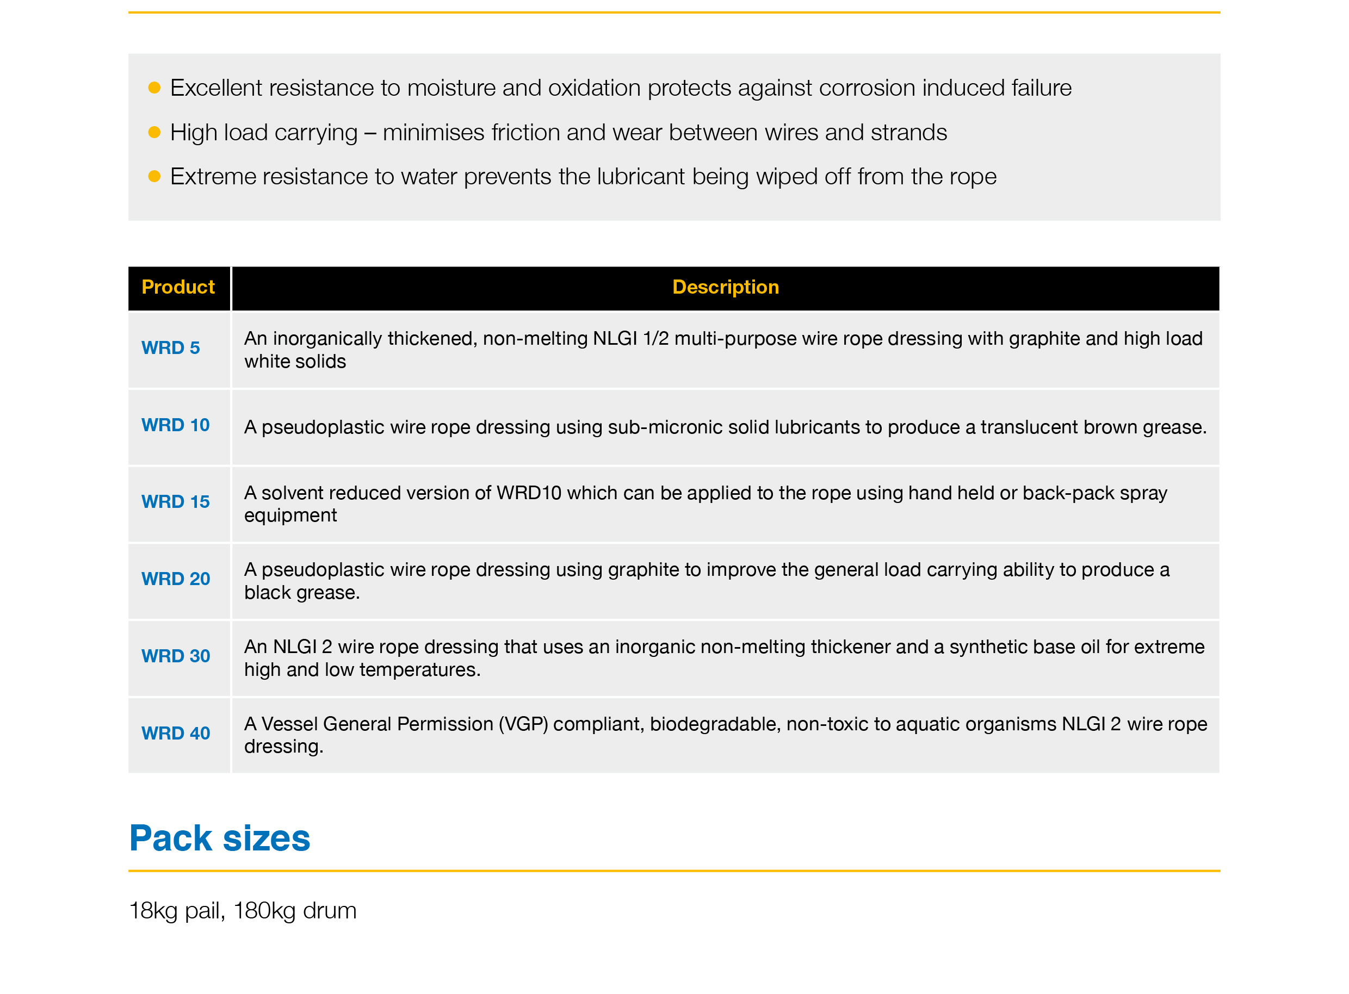

What is a Pseudoplastic grease?

The majority of wear and corrosion of a wire rope occurs in the core. This is hidden away from view and difficult to reach through the outer strands. Therefore an effective rope lubricant must have excellent penetration properties to deliver protection in this vital area.
This is best achieved by low-viscosity materials that have little resistance to flow.
However, low-viscosity products have little resistance to wash-off caused by rain or water immersion – for this, a tenacious high-viscosity material is required. These competing and opposite demands often result in a compromise product.

Rope-Tek™ WRD does not compromise. By utilising a novel thickener system that exhibits
pseudoplastic behavior, Rope-Tek™ WRD provides both excellent penetration and wash-off protection.

