The Metalube PVG™ range of products is a group of fully synthetic industrial greases that has been specifically formulated for the lubrication of valves operating in the petrochemical industry. The unique combination of synthetic base fluid, solid lubricants, corrosion inhibitors and stabilisers ensure that the PVG™ range exhibits maximum resistance to chemicals encountered in the exploration and production of crude oil and gas.
It will act as a lubricant to the valve components and will assist in maintaining or regaining sealing performance to minimise leakage.

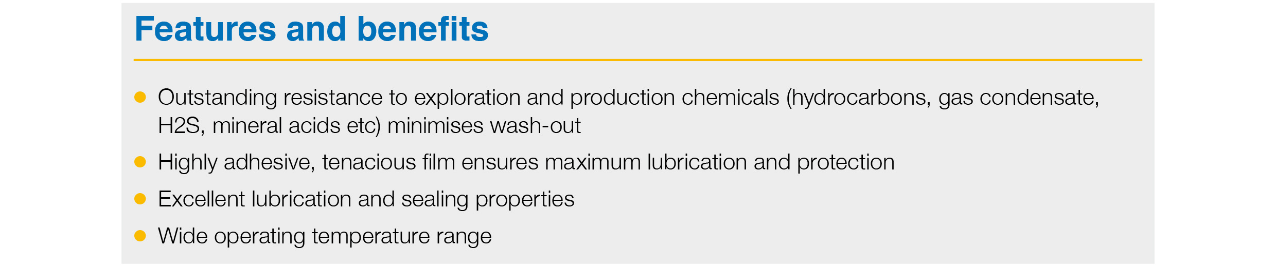

Product Range
PVG™ 679
For use on all types of petroleum valves used in the oil and gas industry with the exception of floating seat ball valves. PVG™ 679 possess outstanding resistance to most chemicals used in oil and gas exploration and production process. It will lubricate and protect valve components ensuring smooth, reliable operation and resist wash-out minimising cavity contamination. The operational temperature of PVG™ 679 is -20°F to 350°F and the pump-able temperature is >30°F.

PVG™ 683
A low temperature version of PVG™ 679 which allows the product to operate down to -40°F
(-40°C).

PVG™ 684
A fluid version of PVG™ 679. PVG™ 684 has been designed for use on floating seat ball valves.

PVG™ Cleaner
PVG™ Cleaner will remove and clean all PVG™ products where conventional solvent-based degreasers will not work.

Pack sizes
Available in 230 kg drums or 22kg pails.

