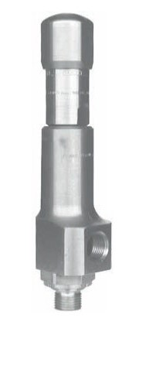
Safety Valves
Type 06315
Safety Valves, angle type, chromium steel, type tested, TÜV-SV.980. D/G/F
Standard safety valve
metal to metal seated, closed bonnet
Inlet: male thread type G (BSPP) acc. to ISO 228/1
Outlet: female thread type G (BSPP) acc. to ISO 228/1

