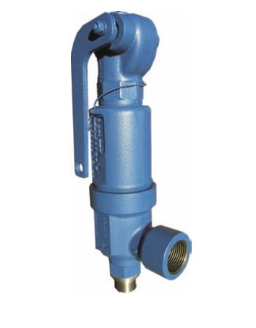
Safety Valves
Type 06310
Safety Valves, angle type, ductile casting GGG-40.3,
type tested, TÜV-SV.909. D/G/F
Full lift safety valve
Standard safety valve for fluids
metal to metal seated,
closed bonnet, with lifting device
Inlet: male thread type G (BSPP) acc. to ISO 228/1
Outlet: female thread type G (BSPP) acc. to ISO 228/1

