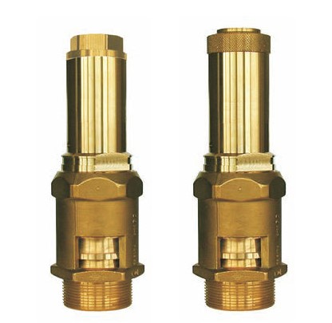
Safety Valves
Type 06218, Type 06219
Safety Valves, brass,
type tested TÜV-SV.1090. D/G
Full lift safety valve
with PTFE O-Ring valve seal,
open bonnet, with discharge holes
Inlet: male thread type G (BSPP) acc. to ISO 228/1

