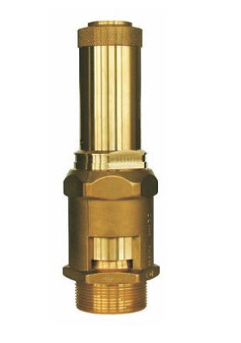
Safety Valves
Type 06216, Type 06217
Safety Valves, brass,
type tested TÜV-SV.1090 D/G
Standard safety valve
with FPM valve seal, open bonnet, with discharge holes
Inlet: male thread type G (BSPP) acc. to ISO 228/1

