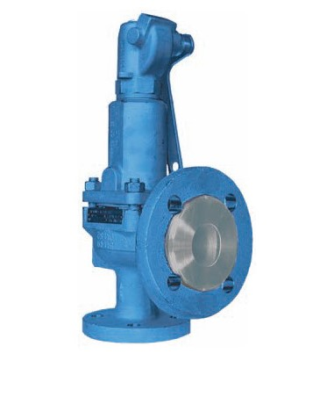
Safety Valves
Type 06340, Type 06341
Safety Valves, angle type, cast iron, type tested, TÜV-SV.576. D/G/F
Full lift safety valve
Standard safety valve for fluids
metal to metal seated, with lifting device,
with enlarged outlet
Flanged connection acc. to DIN EN 1092-1 PN16

