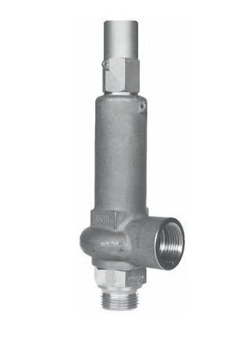
Safety Valves
Type 06319
Safety Valves, angle type, stainless steel,
type tested, TÜV-SV.847. D/G/F (G 3/8 - G 1/2)
type tested, TÜV-SV.878. D/G/F (G 3/4 - G 1-1/4)
metal to metal seated, closed bonnet
Inlet: male thread type G (BSPP) acc. to ISO 228/1
Outlet: female thread type G (BSPP) acc. to ISO 228/1

