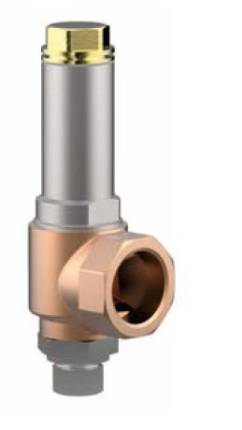
Safety Valves
Type 06388
Cryogenic Safety Valve, angle type, bronze, PN50, type tested TÜV-SV.780. S/G
Full lift safety valve, orifice d0=23mm standard safety valve,
with carbon filled PTFE valve seal, closed bonnet
"cleaned and degreased for oxygen service"

