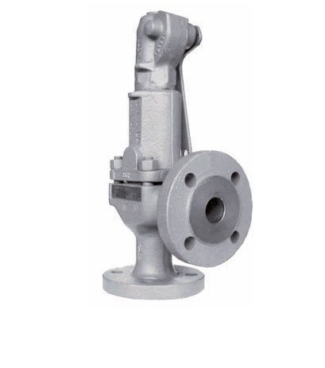
Safety Valves
Type 06127
Safety Valves, angle type, stainless steel
type tested, TÜV-SV.577. D/G/F
Standard safety valve
metal to metal seated, with lifting device,
closed bonnet
Flanged connection acc. to DIN EN 1092-1 PN40

