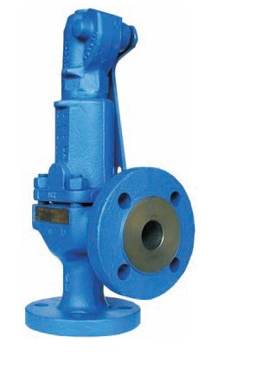
Safety Valves
Type 06125, Type 06126
Safety Valves, angle type, cast steel
type tested, TÜV-SV.577. D/G/F
Standard safety valve
metal to metal seated, with lifting device
Flanged connection acc. to DIN EN 1092-1 PN40

