Safety Valves
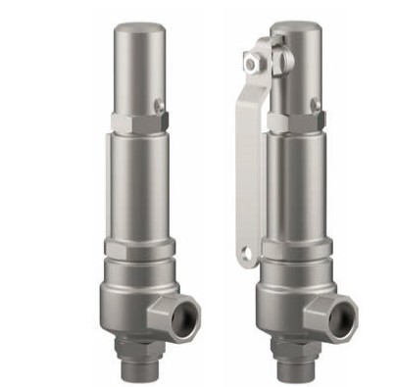
Type 06810, Type 06815
Safety Valves, angle type, stainless steel,
type tested, TÜV-SV.1130. D/G/F
Standard safety valve
metal to metal seated, "cleaned and degreased for oxygen service"
closed bonnet, gastight cap or lifting device
Inlet: male thread type G (BSPP) acc. to ISO 228/1
Outlet: female thread type G (BSPP) acc. to ISO 228/1

