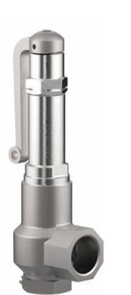
Safety Valves
Type 06805 with bellow seal
Stainless steel bellow sealed Safety Valves, angle type, PN40, type tested TÜV-SV.1105. S/G/L
orifice d0 = 12.5 mm TÜV-SV.1105. only S/G
Standard safety valve,
metal to metal seated, closed bonnet, with lifting device
"cleaned and degreased for oxygen service"

