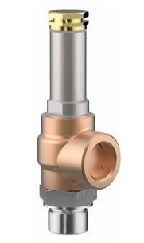
Safety Valves
Type 06472
Cryogenic Safety Valves, angle type, bronze, PN40, type tested TÜV-SV.836. S/G
Standard safety valve,
metal to metal seated, closed bonnet
Outlet: female thread type G 1/2 acc. to ISO 228/1
"cleaned and degreased for oxygen service"

