Safety Valves
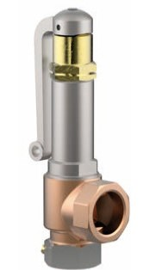
Type 06426
Cryogenic Safety Valves, angle type, bronze, PN40
d0=7,0 & 10,5mm up to PN50,
type tested TÜV-SV.1111. S/G
Standard safety valve,
with PCTFE valve seal (D07 = Metal to metal seated), closed bonnet, with lifting device
" cleaned and degreased for oxygen servive "

