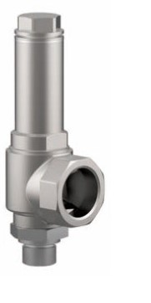
Safety Valves
Type 06383
Cryogenic Safety Valves, angle type, stainless steel, PN50, type tested TÜV-SV.780. S/G
Full lift safety valve, orifice d0=23mm standard safety valve,
with carbon filled PTFE valve seal, closed bonnet
"cleaned and degreased for oxygen service"

