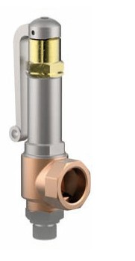
Safety Valves
Type 06425
Cryogenic Safety Valves, angle type, bronze, PN40
d0=7.0 & 10.5mm up to PN50
type tested TÜV-SV.1111. S/G
Standard safety valve,
with PCTFE valve seal (D07 = Metal to metal seated), closed bonnet, with lifting device
"cleaned and degreased for oxygen service"

