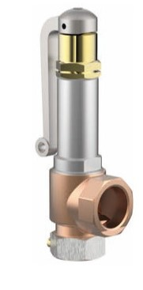
Safety Valves
Type 06417
Cryogenic Safety Valves, angle type, bronze, PN40, type tested TÜV-SV.780. S/G
Standard safety valve (0.2 - 25.0 bar)
Metal to metal seated, closed bonnet, with lifting device
"cleaned and degreased for oxygen service"

