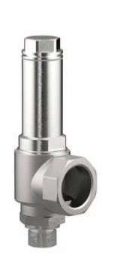
Safety Valves
Type 06381
Cryogenic Safety Valves, angle type, stainless steel, PN40, type tested TÜV-SV.780. S/G
Standard safety valve
Metal to metal seated, closed bonnet
"cleaned and degreased for oxygen service"

