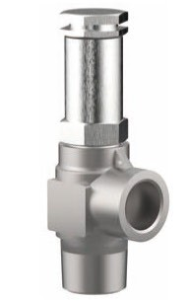
Safety Valves
Type 06011 - gastight
Cryogenic Safety Valves, angle type, stainless steel, PN63, type tested TÜV-SV.1048. S/G/L
Standard safety valve,
complete with carbon filled PTFE valve seal, closed bonnet, gastight
Outlet: female thread Rc 3/8 acc. to ISO 7/1
"cleaned and degreased for oxygen service"

