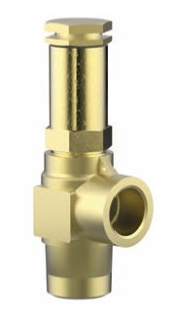
Safety Valves
Type 06002 - gastight
Cryogenic Safety Valves, angle type, brass, PN63, type tested TÜV-SV.1048. S/G
Standard Safety Valve,
gastight, closed bonnet
with carbon filled PTFE valve seal
Outlet: female thread Rc 3/8 acc. to ISO 7/1
"cleaned and degreased for oxygen service"

