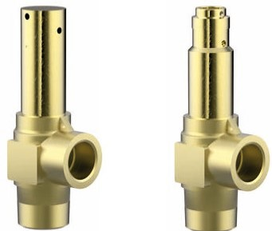
Safety Valves
Type 06002, Type 06006
Cryogenic Safety Valves, angle type, brass, PN63, type tested TÜV-SV.1048. S/G
Standard safety valve, with carbon filled PTFE valve seal
Outlet: female thread Rc 3/8 acc. to ISO 7/1, " cleaned and degreased for oxygen service "

