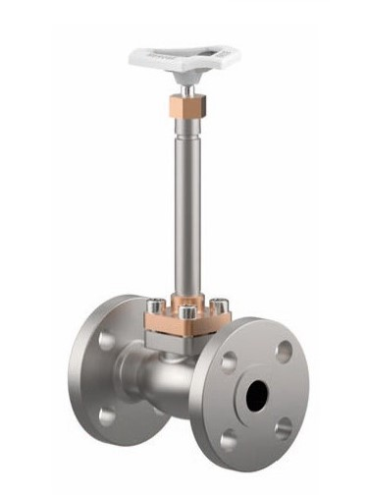
Globe Valves
Type 03321 - Globe Valve, ANSI Flanges
Cryogenic-Globe and Globe/Check Valves, class 300
Stainless steel body and bronze topwork,
" live loaded " gland packing
" cleaned and degreased for oxygen service "

