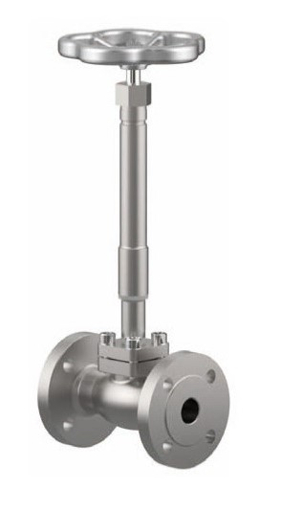
Globe Valves
Type 03252 - Bellow Sealed Globe Valve
Cryogenic-Bellow Sealed Globe Valve, class 300
Stainless steel body and topwork,
" live loaded " gland packing
" cleaned and degreased for oxygen service "

