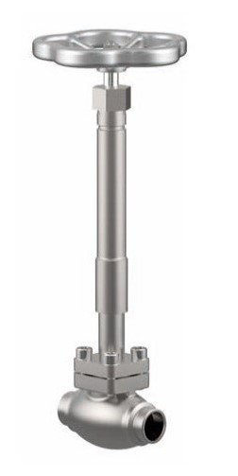
Globe Valves
Type 01252 - Bellow Sealed Globe Valve
Cryogenic-Bellow Sealed Globe Valve, PN50
Stainless steel body and topwork,
" live loaded " gland packing
" cleaned and degreased for oxygen service "

