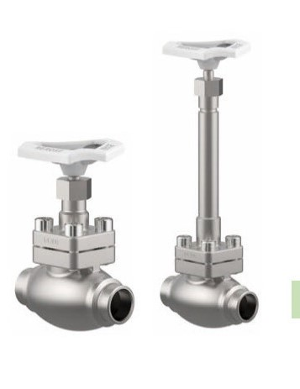
Globe Valves
Type 1116 - Globe Valve
Cryogenic-Globe Valves, PN50
Stainless steel body and topwork,
Inner parts made of stainless steel
" live loaded " gland packing
" cleaned and degreased for oxygen service "
Available options - on request only:
· Welded stainless steel stubs acc. to ISO 1127 or
ASTM A312 - length FF + 200mm
· Extension H up to 900mm
· Valve with control disc (tapered design)
· Disc with PTFE/Carbon filled (25%) seal
· Further connection types

