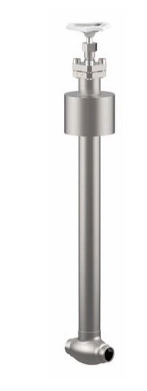

Globe Valves
Type 01420 - Top-Entry-Valve
Cryogenic-Globe Valves, PN50
Stainless steel body and topwork,
" live loaded " gland packing
" cleaned and degreased for oxygen service "

