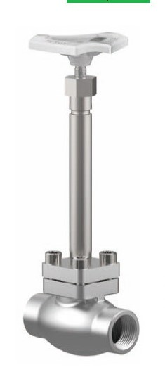
Globe Valves
Type 01345 - Globe Valve
Cryogenic-Globe and Globe/Check Valves, PN50
Stainless steel body and topwork,
" live loaded " gland packing
" cleaned and degreased for oxygen service "

