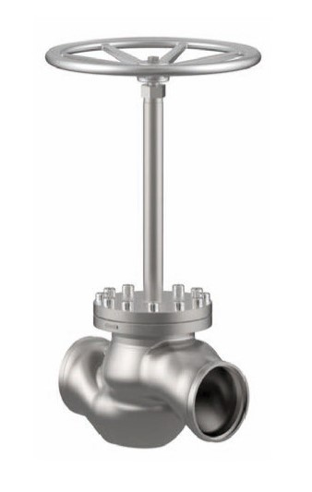

Globe Valves
Type 01341 - Globe Valve
Stainless steel body and topwork
" live loaded " gland packing

