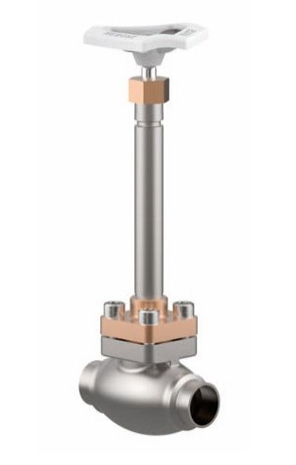

Globe Valves
Type 01321 - Globe Valve
Cryogenic-Globe and Globe/Check Valves, PN50 (DN100/150=PN40)
Stainless steel body and bronze topwork
" live loaded " gland packing
" cleaned and degreased for oxygen service "

