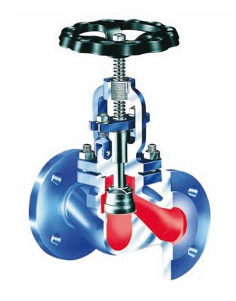
Globe Valves
Type 03080
Globe Valves, PN16, DIN 3356-1
Body and topwork in cast iron
seat and disc in stainless steel, metal to metal seated
Flanged connection acc. to DIN EN 1092-1 PN16
face-to-face dimension acc. to DIN EN 558-1, Reihe 1
Available options - on request only:
· Angled Valves
· Valve with control disc

