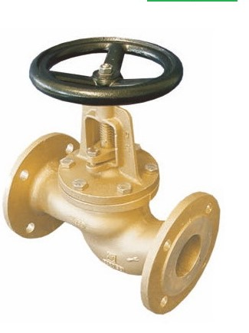
Globe Valves
Type 03050
Globe Valves, PN16, DIN 86 260-A
Bronze body and topwork
metal to metal seated
Flanged connection acc. to DIN EN 1092-1 PN16
face-to-face dimension acc. to DIN EN 558-1, Reihe 1
Available options - on request only:
· Disc with PTFE seal
· Valve with control disc (tapered design) and PTFE seal

