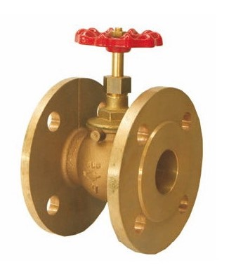
Globe Valves
Type 03021
Globe Valves, PN16
Bronze body, screwed topwork in brass
Flanged connection acc. to DIN EN 1092-1 PN16

