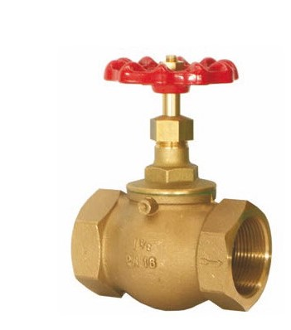
Globe Valves
Type 01021
Globe Valves, PN16, DIN 3844
Bronze body, screwed topwork in brass
Female thread connection (G) acc. to ISO 7-1 Rp
Available options - on request only:
· Handwheel in plasic DIN 388-1
· Valve with safety plate in brass

