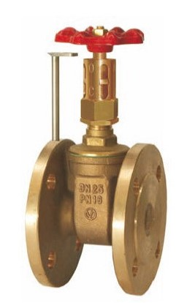
Gate Valves
Type 09420
Flanged Gate Valves, PN16, DIN EN 12288
Bronze body, screwed topwork in brass
with maintenance-free gland packing (O-Ring)
and non rising stem
flanged connection acc. to DIN EN 1092-3 PN16

