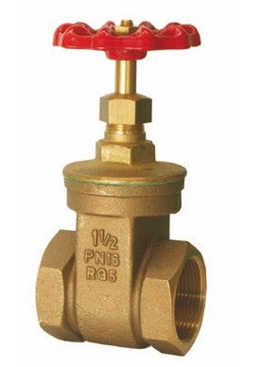
Gate Valves
Type 09061
Gate Valves, PN16, DIN EN 12288
Bronze body, screwed topwork in brass
with gland packing and non rising stem

