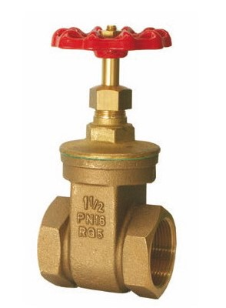
Gate Valves
Type 09010
Gate Valves, PN16, DIN EN 12288
Bronze body, screwed topwork in brass
with gland packing and non rising stem
Part No. 09010.X.0000
Female thread connection (G) acc. to ISO 7-1 Rp

