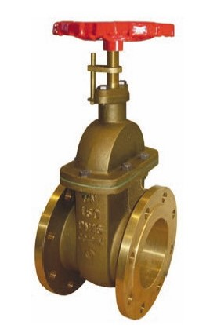
Gate Valves
Type 09320
Flanged Gate Valves, PN10 - 16, DIN EN 12288
Bronze body and topwork
with maintenance-free gland packing (O-Ring) and non rising stem
flanged connection acc. to DIN EN 1092-3 PN10 or PN16

