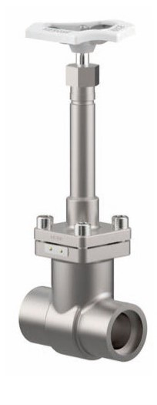

Gate Valves
Type 09340 - Gate Valve
Cryogenic-Gate Valves, PN50
Stainless steel body and topwork,
one way tightening (in flow direction),
" live loaded " gland packing
" cleaned and degreased for oxygen service "

