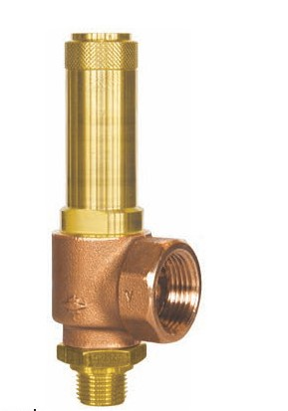
Safety Valves
Type 06605
Safety Valves, angle type, bronze, type tested TÜV-SV.1080. D/G
Standard safety valve
with O-ring valve seal,
closed bonnet, with lifting device,
with enlarged outlet
Inlet: male thread NPT acc. to ANSI B 1.20.1
Outlet: female thread type G (BSPP) acc. to ISO 228/1

