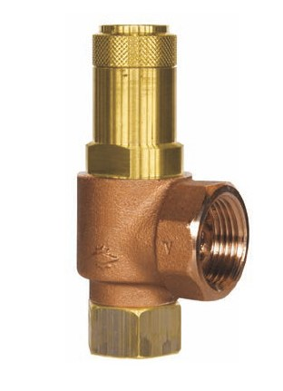
Safety Valves
Type 06602
Safety Valves, angle type, bronze, type tested TÜV-SV.1080. D/G
Standard safety valve
with O-ring valve seal,
closed bonnet, with lifting device,
with enlarged outlet
In- and outlet: female thread type G (BSPP) acc. to ISO 228/1

