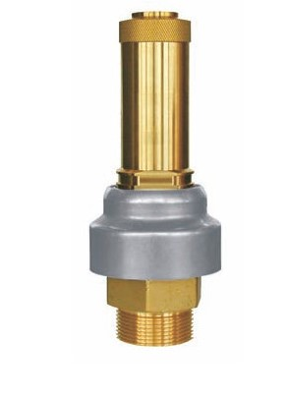
Safety Valves
Type 06505
Safety Valves, brass,
type tested TÜV-SV.948 Liquid/ Granular/ Powder
Standard safety valve
with FPM valve seal, closed bonnet,
with diaphragm for protection of the spring, with lifting device,
discharge holes with protection cap
Inlet: male thread type G (BSPP) acc. to ISO 228/1

