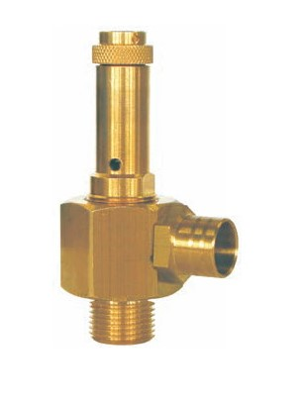
Safety Valves
Type 50051.0011
Safety Valves, angle type, brass, type tested TÜV-SV.1009. D/G
Standard safety valve
with EPDM valve seal for vapours and gases
open bonnet, with lifting device
Outlet: female thread M15x1 with installed hose nozzle
Inlet: male thread type G (BSPP) acc. to ISO 228/1

