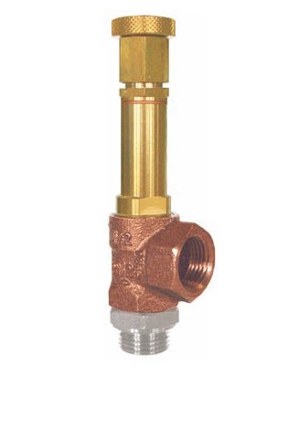
Safety Valves
Type 50051.0004
Safety Valves, angle type, bronze
Lloyds Register Approval LR-TA 92/20011
Standard safety valve
metal to metal seated,
closed bonnet, with lifting device
Inlet: male thread type G (BSPP) acc. to ISO 228/1
Outlet: female thread type G (BSPP) acc. to ISO 228/1

