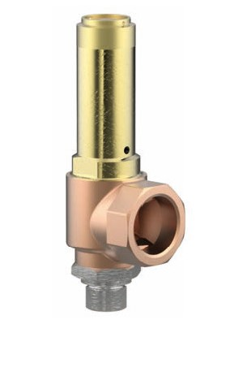
Safety Valves
Type 06395
Safety Valves, angle type, bronze, type tested TÜV-SV.910. D/G
Standard safety valve, open bonnet, with lifting device and enlarged outlet
Outlet: female thread type G (BSPP) acc. to ISO 228/1

