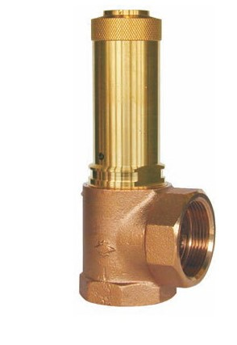

Safety Valves
Type 06380
Safety Valves, angle type, bronze, type tested TÜV-SV.749. D/G
Standard safety valve
with soft valve seal, open bonnet, with lifting device
In- and outlet: female thread type G (BSPP) acc. to ISO 228/1

