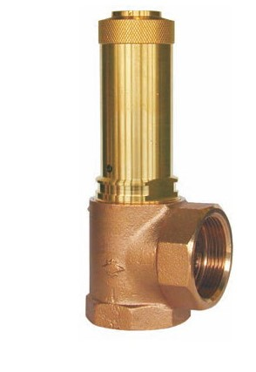
Safety Valves
Type 06376
Safety Valves, angle type, bronze, type tested TÜV-SV.749. F
Standard safety valve
with soft valve seal for fluids, open bonnet,
with diaphragm for protection of the spring, with lifting device
In- and Outlet: female thread type G (BSPP) acc. to ISO 228/1

