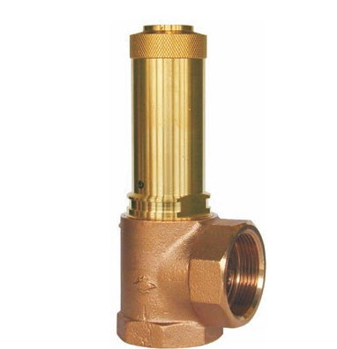
Safety Valves
Type 06372
Safety Valves, angle type, bronze, type tested TÜV-SV.749. S/G
Standard safety valve
with soft valve seal for saturated steam, air and similar gases, open bonnet,
with diaphragm for protection of the spring, with lifting device
In- and outlet: female thread type G (BSPP) acc. to ISO 228/1

