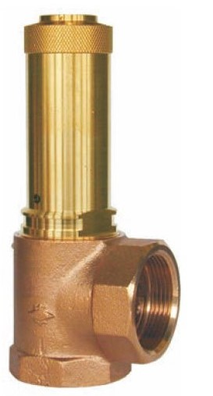
Safety Valves
Type 06347
Safety Valves, angle type, stainless steel
type tested, TÜV-SV.576. D/G/F
Full lift safety valve
Standard safety valve for fluids
metal to metal seated, with lifting device,
closed bonnet, with enlarged outlet
Inlet: Flanged connection acc. to DIN EN 1092-1 PN40
Outlet: Flanged connection acc. to DIN EN 1092-1 PN16

