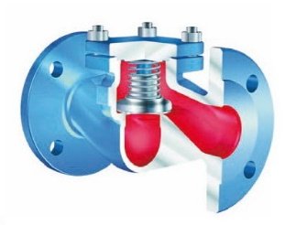
Check Valves
Type 05115
Check Valves, PN40
Body in cast steel
seat and disc in stainless steel, metal to metal seated

